Date: 11th Nov 2021

Duration: ca. 5 minutes

What to present:

1. Overview of the project and the team

2. Demonstration of project outcomes

3. Presentation of key technical decisions

4. Risks, challenges during the project, how have you deal with them?

5. Lesson learned for you, for your team

Link to excel:

<https://docs.google.com/spreadsheets/d/1S26neHQ148gwf1FeTG3QR4spPuA5mYTmZ4qaUARclDU/edit?usp=sharing>

Assignment 4:

* List all food’s information(menu)
* Filter foods by category(search, option filter)

Front end: html css image, category (code page)

Back end: routing, viet action add, delete, filter

Menu : 10-15 items

Backend: Thien, Dinh, Chuong

Front end + menu: Phong + Hoan

Script:

Dl assignment 4 :

now -> 3/11: tu xu

report, documenting

4/11: meet, check 1 lan r viet docs

6/11: finalize report, push code to git

toi thu 2 7/11 8h

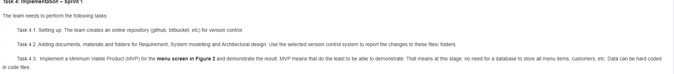

**Overview**

A web app with two main views, staff and customers, customers can order and pay for the stuff they called.

The Starfish POS makes it possible for customers to order and communicate with personnels for some requests without having to install an app.

Formerly developed to be pure html css and JS, The POS now is based on ExpressJS and EJS, to allow easier data insertion and modification of the menu.

It contains 2 views, customers and staff. The customers can purchase and add courses to the cart.

Guests can use the web immediately after scanning the QR code, they can order and also reserve a table, later they can also give feedback.

Staff must login to have the access, in order to add, delete courses of pending cart. (currently not developed yet), they can also add a new dish to the menu, the option is also not developed.

The payment system is not implemented as well.

After payment, customers can choose to print the bill or not.

* Note: The project currently runs only in localhost, as we haven’t found the host that supports running Node.js module, a pure html, css, and javascript version, can be found [here](http://starfishrestaurant.infinityfreeapp.com/).

Content of the source code:

* 1 server JS file to maintain basic requests.
* public folder contains: css, images and js for resources used in the project.
* Node modules: contain expressJS and EJS view engine package.

**Demonstration of project outcomes**

Make a website to simplify the process of ordering food.

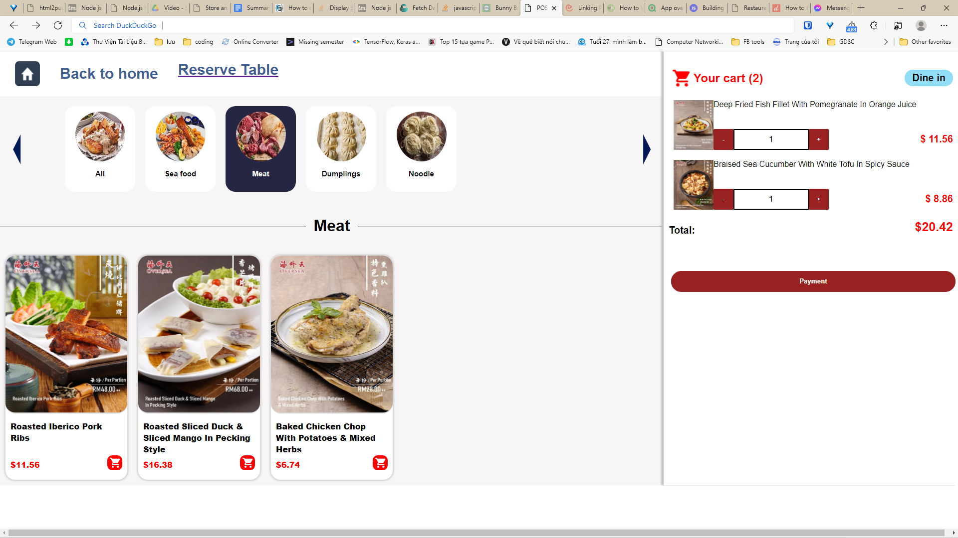

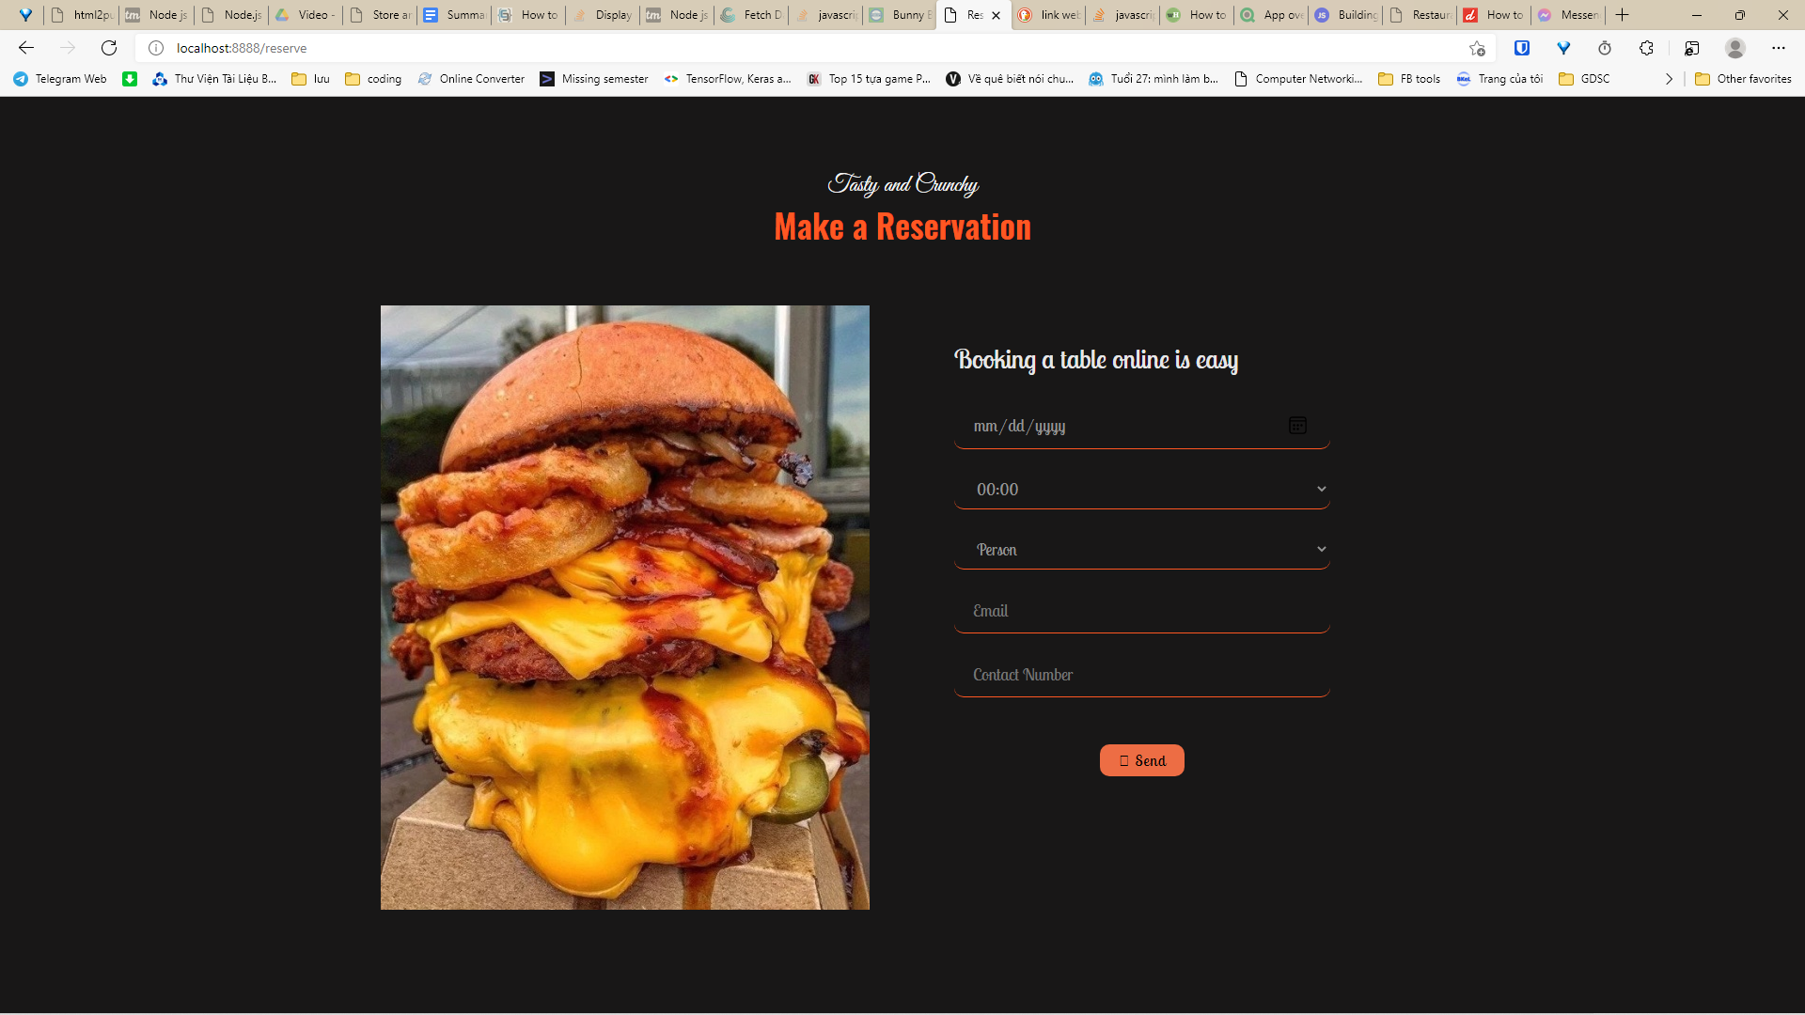

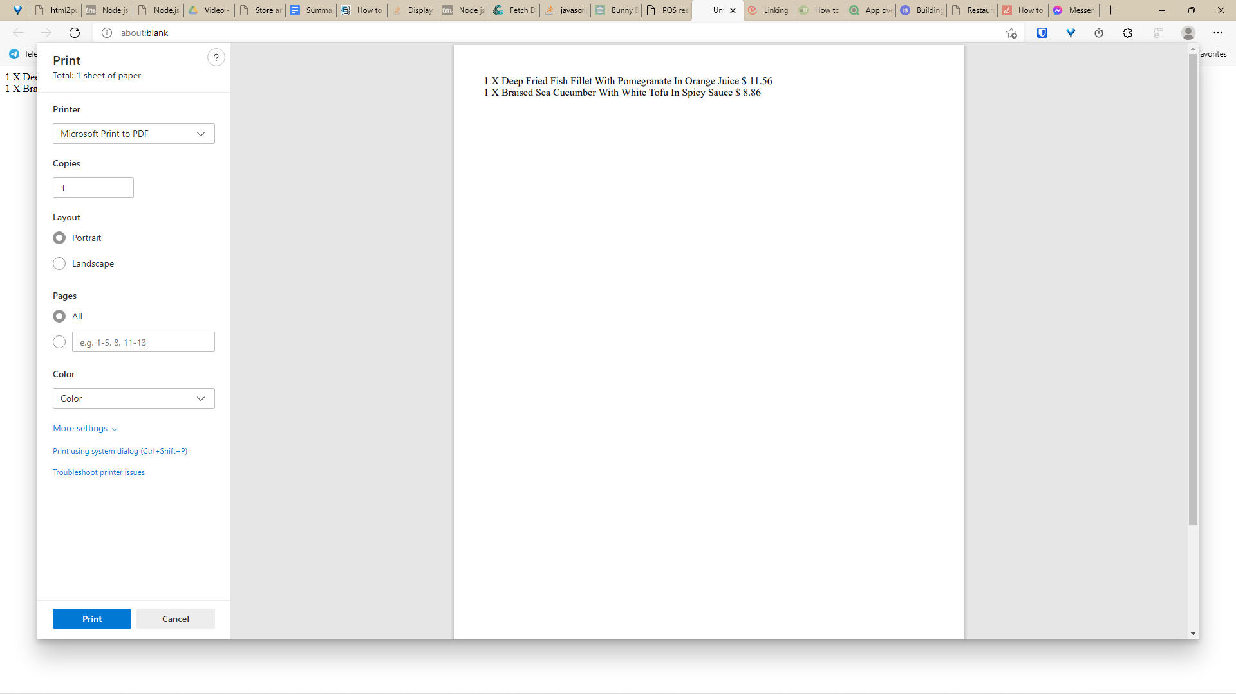

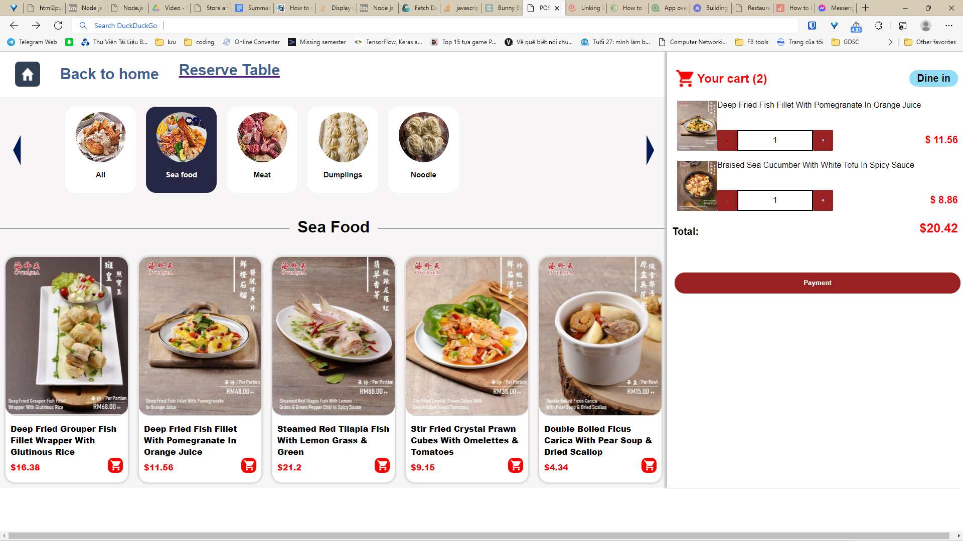



**Presentation of technical decision**

At first, We intended to use HTML, CSS, and JS.

But, at the last second, we switched to ejs for its ability to inject dynamic content into the web page and expressJS.

We wanted to use only expressJS, but the layouts were terrible, so we decided to add some css and use ejs as a view engine to render the web page.

Another reason for using EJS is that its syntax is similar to html’s, so it takes much less time to practice and also it supports partials, which saves us a lot of time again because we can avoid writing the same line of code over and over by simply referring to partials.

**Risk challenge? How are they handled?**

The git usage is quite confusing for some members, one of them accidentally overwritten a usage version with a corrupted one.

=> One cloned a working version locally, repush the code.

All of us have multinary projects alongside so not spending much time on development.

=> Decided to have 5 last days to develop the app only.

As the result of the above, we have much time to find a suitable host for our Node.js app.

=> The app remains local.

Time limitations.

Conflicts between team members.

Communication: ??

| Lack of knowledge about the language we're going to use => Teamwork, study more |
| --- |
| Not enough time => Reduce spare time |
| Communication => Accept the reality and communicate through online applications |

**Lesson learnt from the Sprint 1?**

Teamwork: group cohesion, communication, commitment, accountability.

time management: planning weekly tasks, providing clear instructions and expectations for team members, and having concrete schedules in advance.

Communication is the key: listen to facilitate effective team communication, be mindful of your messaging, practice how you communicate with coworkers.

**Source code:**